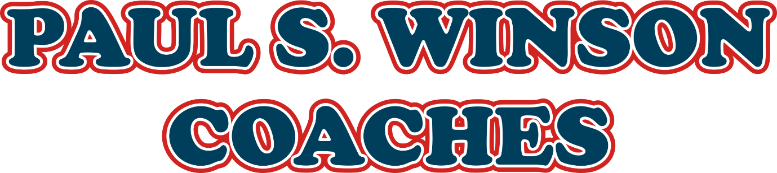
TBT12 Toolbox Talk – Arrival Destination Vehicle Check
Company: Paul S. Winson Coaches of Loughborough
Audience: PCV Drivers
Topic: Arrival Destination Vehicle Check
Date: Shown on sigh off document
Delivered by: Matthew Winson

Purpose of This Toolbox Talk
To remind all drivers about the importance of thoroughly checking your coach as soon as you arrive at your destination.
This early check helps us:
- Spot any damage immediately
- Keep passengers safe on the return journey
- Plan any necessary repairs without last-minute panic
- Maintain our professional reputation

Policy Requirement
ALL drivers must perform a walk-round inspection immediately after parking at destination, before leaving the vehicle unattended or taking a break.
This check is mandatory for:
- Day trips
- Private hires
- Tour work

Key Areas to Check
Tyres
- Look for damage from kerbs or obstacles when manoeuvring.
- Check for cuts, bulges, scuffs, or signs of deflation.
- Report any suspected damage straight away.
Wheel Nuts
- Check all wheel nuts are in place.

- If wheel pointers are fitted check, there pointing together.

- Check for signs off loosing tightness, like rust streaks on the wheel.
Bodywork
- Check for scrapes, dents, or impact damage.
- Pay special attention to corners, skirts, wheel arches, and mirror arms.
- Look for marks from walls, posts, or street furniture.
Doors and Panels
- Ensure passenger doors open and close correctly.
- Look for damage from tight parking spaces or obstructions.
Mirrors and Cameras
- Make sure mirrors and camera housings are intact and properly positioned.
- Check for cracks or breakages.
Lights and Indicators
- Confirm lenses are intact and undamaged.
- Look for cracks or impacts that may have broken the lens.

Why This Is So Important
- Early Detection: Gives time to plan and arrange repairs.
- Passenger Safety: Damaged tyres or bodywork can make the return trip unsafe.
- Professional Standards: Avoids last-minute surprises before departure.
- Cost Control: Early reporting limits further damage and costly emergency repairs.
- Company Reputation: Shows we’re professional, safe, and reliable.

Driver Responsibilities
- Do the check immediately after parking.
- Report damage or defects without delay using company procedures.
- Record findings clearly in the defect book or electronic system.
- Advise traffic office or engineering if repairs are needed before the return trip.
- Never ignore or conceal damage—it must be reported.

Management Commitment
Paul S. Winson Coaches is committed to:
- Making defect reporting quick and easy.
- Planning repairs efficiently to avoid delays.
- Maintaining the highest safety and presentation standards.

Enforcement
Failure to follow this policy may result in:
- Disciplinary action.
- Personal accountability for unreported damage.
- Impact on professional driving duties.

Summary
- Always do a walk-round check on arrival.
- Look carefully for tyre and bodywork damage.
- Report issues immediately so repairs can be arranged in time.
- Keep everyone safe, protect our reputation, and deliver excellent service.

Discussion Points
- Any challenges in doing these checks?
- Any recent issues with damage not being reported early enough?
- Ideas to improve our process or make reporting easier?

Sign-Off
By signing the signature below, you confirm you have attended this briefing and understand your responsibilities for the arrival destination vehicle checks.

