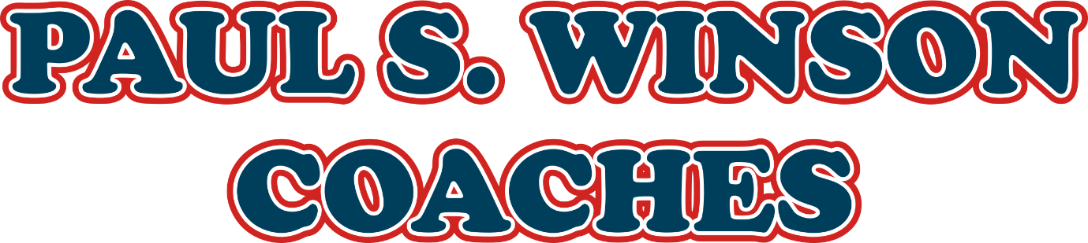

TBT13 Toolbox Talk: Blue Light Incident Response
Company: Paul S. Winson Coaches of Loughborough
Topic: Responding to Serious Incidents (Blue Light Incidents)
Audience: All Staff – Drivers, Engineers, Office, Management
Delivered By: Matthew Winson / Paul Winson
Date:
Duration: 10–15 minutes

What Is a Blue Light Incident?
A Blue Light Incident is any serious event involving:
- Emergency services attendance (police, fire, ambulance)
- Risk to life or public safety
- Potential impact on the company’s reputation

Why It Matters
In a major incident, how we act as a company and as individuals reflects on our professionalism, our safety culture, and our legal position.

Immediate Priorities
- Safety First – Support anyone injured or involved
- Call Emergency Services – Ensure help is on the way
- Notify the Office Immediately – We need to act fast
- Send a Company Rep to the Scene – We won’t leave you alone
- Only Answer Basic Police Questions – Wait for legal support
- Stay Calm and Professional – We’ll handle the rest

Driver Support
If you're the driver:
- You are NOT alone – We will support you
- You may be tested for drugs or alcohol – this is standard
- Stay quiet on details until a lawyer is present
- Keep calm – let us deal with the authorities and insurance (after insurance form completion)
- We’ll ensure you’re safe, hydrated, and looked after

Behind the Scenes
While the incident unfolds, the transport office will:
- Gather vehicle and journey documents
- Retrieve tacho data
- Prepare insurance info and staff records
- Liaise with emergency services and media if needed

Follow-Up Support
- You’ll get welfare support
- We’ll handle insurance and legal contact
- We’ll update other staff and customers appropriately
- The vehicle will be recovered if needed
- A trained investigator will carry out a thorough review

Key Points to Remember
- Keep your vehicle clean, legal, and roadworthy
- Make sure you are fit to drive each shift
- Update your licence, DQC, and eyesight checks when requested
- Know who to call in an emergency
- Don't engage with media or make public comments – let the company handle it

Final Message
We hope never to use this plan—but if the worst happens, we are prepared, and we will protect you, our customers, and our company.
Sign-Off
By signing the signature below, you confirm you have attended this briefing and understand your responsibilities for the arrival destination vehicle checks.

